Social Media Posts Predicting Journal Articles in the News
Shawn Dust
Northern Illinois University
100 Normal Rd, DeKalb, IL
Z1810459@students.niu.edu

ABSTRACT

Author Retains Copyright. Copyright Shawn Dust, 2017
As social media has gained traction as a vector of idea spread, its influence on what is newsworthy has become a veritable subject of research. In particular, this paper focuses on how frequency of mentions on social media relates to scholarly journal articles being mentioned in the news. The best result was from the Support Vector Machine, at 0.876.

Keywords
Altmetrics, Newsworthy Research, Journal Articles, Twitter, Facebook.

INTRODUCTION
Researchers are very motivated to have their research published, both in journals and in the news. These accomplishments signal certain qualities about the article such as usefulness, entertainment, and relevance to a given population’s lives. This study aims to begin the discussion of which articles are newsworthy so that in the future the features of such newsworthy articles may be discovered and factored into the research and writing process.

DATA collection
The dataset used for this project was initially cleaned and collected from the Altmetric database by Harish Siravuri. It includes data on a large set of scholarly journal articles, how often they were mentioned on social media (Twitter, Reddit, Facebook, GooglePlus, etc.). I further refined the dataset by removing outliers which only served to make the majority of the data take up less space on the graph, thus impeding a visual analysis.

FEATURE SELECTION
In order to determine which variables might most relate to journal articles being in the news, I first performed a simple correlation between various social media sources and the news article data. My findings follow in Table 1:

 | Correlation
Mendeley | 0.0168
H-Index | 0.0402
GooglePlus | 0.0760
Facebook | 0.2698
Twitter | 0.3895
Table 1
Clearly, certain indicators such as Mendeley seem to have little correlation with newsworthiness, while others, such as Twitter and Facebook, seem to have high correlations.
In addition to exploring the simple correlation, I also explored the Spearman correlation, which ranks datasets in order, instead of using the values which determine that ordering. The results are below in Table 2:
 | Spearman Correlation | Absolute Change
Mendeley | 0.1316 | +0.1148
H-Index | 0.0600 | +0.0198
GooglePlus | 0.0506 | -0.0254
Facebook | 0.3114 | +0.0416
Twitter | 0.0932 | -0.2963
Table 2
As you can see, the Spearman Correlation for this data is slightly higher for some social media, but much lower for Twitter. In the end, I decided the standard correlation was more useful. Using standard correlation, it is obvious that Twitter and Facebook are the variables most highly correlated with articles appearing in the news.
Below in Figure 1, the scatter plot for Facebook posts versus newsworthiness is shown. As you can see, if a regression line were to be drawn, it would not hit many points. The data is vary scattered into an “L” pattern, with extra samples scattered around. So, in later steps, I decided to binarize the news data. So, instead of considering how often a news article was in the news, I considered simply whether or not an article was mentioned in the news.

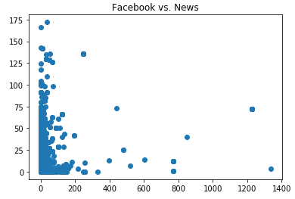
Figure 1: Facebook vs. News

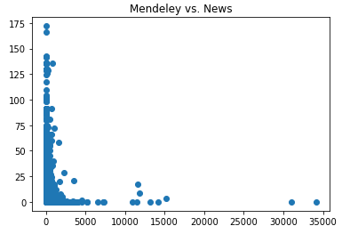
Figure 2: Mendeley vs. News
Mendeley in this graph appears only slightly less appealing than using Facebook data. It seems the regression line might hew close to the y-axis. And a curve might approximate y = 1/x.

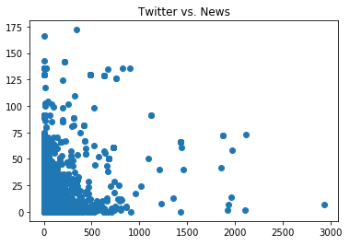
Figure 3: Twitter vs. News
The scatter plot graph on Twitter (Figure 3) looks a little more promising. We can see a better distribution, though it looks like a “shotgun” scatter pattern.
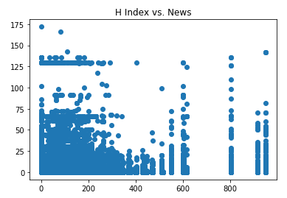
Figure 4: H Index vs. News
H Index rankings versus newsworthiness probably present the most curious of all the graphs so far. It appears that scores are discreet, often with large gaps in between values (vertical lines). Also, it appears that certain frequencies of journal articles appearing in the news were quite common (horizontal lines).

METHODS
In order to explore this concept in more detail, I created a new field in the data set named “News Binary”. If an article received any news coverage at all, this value was “1”, if none, then the value was “0”. I then graphed out where these articles gained traction, looking to see at what threshold a journal article could be expected to have news coverage. The results follow:
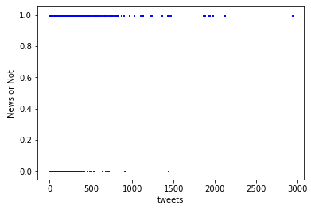
Figure 1
Figure 1 clearly shows that after about 750 tweets, the probability of an article reaching the news is near certain. At almost 1500 tweets, it becomes certain.
Figure 2 shows a similar trend. Once a journal article has nearly 400 shares on Facebook, this data shows that we would expect that journal article to be mentioned in the news.
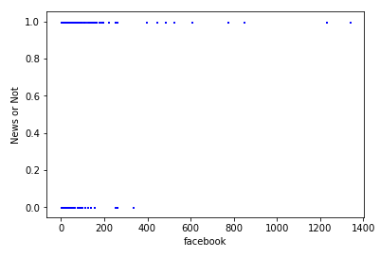
Figure 2
Figure 3 shows an opposite trend on Reddit. As the number of engagements increases, the likelihood of an article reaching the news decreases. From this graph, that limit is found when approaching 40 from the minus side.

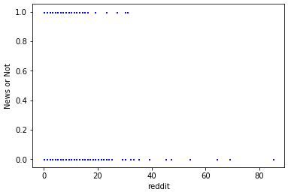
Figure 3

Figure 4 displays GooglePlus data. It appears that the number of GooglePlus plusses does not relate to whether the given article is mentioned in the news.

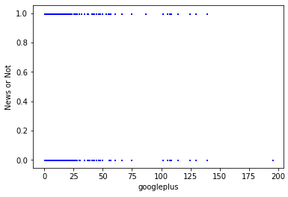
Figure 4
From these initial tests, Facebook and Twitter posting activities are clearly the most related to journal articles becoming news, with respect to the other social media.
Having selected Twitter and Facebook posts as the most closely related to an article being mentioned in the news, those two will receive focus in the following analysis.

results
The three classification models I selected produced decent results. The greatest accuracy was found in the Support Vector Machine (SVM). This was followed closely by Random Forest and Multinomial Naïve Bayes. The accuracy, precision, and recall values and the F-1 scores of each of the models are presented in Table 1. The receiver operating characteristics (ROC) are shown in Figures 5, 6, and 7.
 | MNB | RF | SVM
Accuracy | 0.858 | 0.874 | 0.876
Precision | 0.770 | 0.744 | 0.733
Recall | 0.052 | 0.248 | 0.253
F1-Measure | 0.098 | 0.371 | 0.377
Table 3. Accuracy, precision, recall and F1 scores
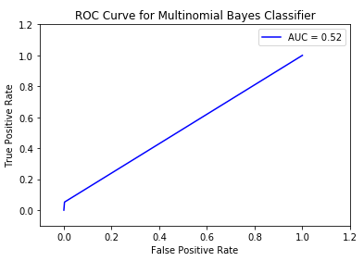
Figure 5. ROC curve for Multinomial Naïve Bayes
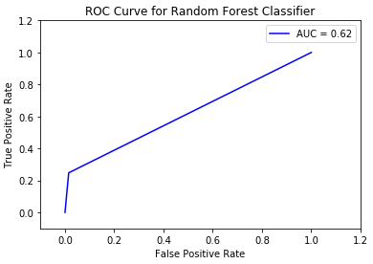
Figure 6. ROC curve for Random Forest
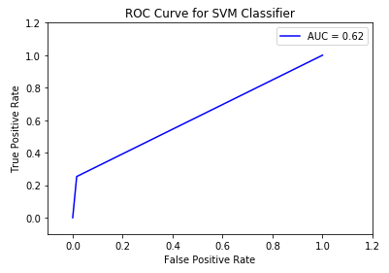
Figure 7. ROC curve for Support Vector Machine
Figure 1. ROC curves for each classification model

Of the two features most strongly considered in this analysis, Facebook came out as the strongest, accounting for almost 60 percent of the effect in the Random Forest classifier.
Feature | Random Forest | MNB
Facebook | 0.574495 | -1.7101
Twitter | 0.425505 | -0.1995
Table 4. Relative significant of features

Conclusions AND future work
In this study, I explored the relative importance of multiple social media platforms to determine which one’s activity best predicted mentions in the news. I used initial insights from graphs showing the relationship between a given social medium and the binary news variable (‘News or Not’) to determine where clear relationships might exist. In some cases, they did. The Support Vector Machine produced the best results, followed closely by Random Forest and Multinomial Naïve Bayes. These findings point to the idea that journal article readers may be able to influence which articles are covered in the news by interacting with those articles on social media by sharing or tweeting. In the future, I plan to break down the data to be even more granular: looking at the dates of social media posts, to try to discern a cause and effect relationship between social media activity surrounding an article and whether and how often it was mentioned in the news. Also, I plan to try a neural network in the future to see if I can improve upon the current accuracy scores. Additionally, it may be useful to produce regression models for the purpose of predicting at what threshold a given article can be expected to be picked up in the news. Perhaps also in the future Natural Language Processing will come into play so that the contextual features of a newsworthy article may be discovered. This would be valuable information for scholarly researchers writing journal articles.

